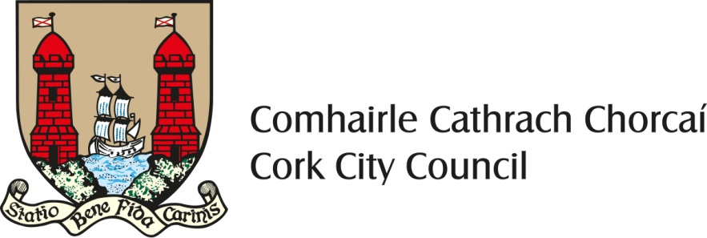

Cork City Council Waste Prevention Grant Scheme 2023

The purpose of the scheme:
This grant is funded by the Community, Culture & Placemaking Directorate of Cork City Council as part of its Waste Prevention Programme and its commitments under the Southern Region Waste Management Plan 2015-2021 (Ref: Action Policies B.1.2 and B.2.).
This scheme aims to support Cork city groups to implement waste prevention, re-use and repair activities in their local community and to encourage partnership between local businesses, schools, charities, community and voluntary groups.
What is Waste Prevention?
Essentially waste prevention a process of re-thinking how we do things in order not to create waste. Preventing waste is about finding ways to keep items in use longer and not generating as much waste in the first place. It’s about:
- rethinking the way we do things;
- redesigning the items we use;
- repairing and reusing items;
- building knowledge and skills in the community to facilitate repair and reuse;
- changing attitudes and behaviour in regard to what we buy and what we throw away;
but most of all:
- working together and thinking creatively to do something about it.

Cork City Council may pay a waste prevention grant up to a maximum of €1,000 to voluntary or community groups or schools for waste prevention / reuse / repair / upcycling projects in their local community.

Please note that October is Re-Use month and that successfully funded projects may be requested to show case their results and/or be part of at least one Re-Use Month planned events in Cork City.

How to apply:
- The waste prevention grant application form is available at the end of this document or from the Community, Culture & Placemaking Directorate, Cork City Council (environmentccp@corkcity.ie) or available to download from the Cork City Council Website (www.corkcity.ie)

- The application form should be completed and returned to the Environmental Awareness Officer, Community, Culture & Placemaking Directorate for consideration by the closing date Friday 31st March, 2023.

Payment of grants:

- The applicants will be informed whether their application has been successful or not by Monday 24th April 2023.

- 50% of the grant shall be paid at the beginning of the project. Payment of the remaining 50% will be made on submission of a completion report. Grants shall be paid to the name of the organisation specified on the grant application form. Please ensure that this name is the same as the name on the organisation’s bank account.

- Please be advised that any grant that remains unclaimed by 15th December, 2023 will be cancelled.

Waste Prevention Grant Scheme – 2023

Name of Organisation: ________________________________________________________________
(if application is successful and awarded grant, the grant payment will be made out in this name ONLY)

Contact Name: ______________________________________________________________________

Position in Group (i.e. Secretary, Chairman, etc): __________________________________________

Contact Number(s): _____________________________E-mail address: _______________________

Name and address to which correspondence is to be sent: ____________________________________

___________________________________________________________________________________

Location of proposed project: __________________________________________________________

Details of project you are seeking funding for (please include additional information if you wish): ______

___________________________________________________________________________________

___________________________________________________________________________________

___________________________________________________________________________________

___________________________________________________________________________________

___________________________________________________________________________________

___________________________________________________________________________________

___________________________________________________________________________________

___________________________________________________________________________________

___________________________________________________________________________________

___________________________________________________________________________________

___________________________________________________________________________________

___________________________________________________________________________________

___________________________________________________________________________________

___________________________________________________________________________________

Details of how outcomes of the project will be measured: _____________________________________

___________________________________________________________________________________

___________________________________________________________________________________

___________________________________________________________________________________

Benefits that the project will bring to the Community: _________________________________________

___________________________________________________________________________________

___________________________________________________________________________________

___________________________________________________________________________________

___________________________________________________________________________________

___________________________________________________________________________________

- Date of commencement of project: ____________________________________________________

- Proposed date of completion: ________________________________________________________

- Financial Details:

- Total Estimated Cost of Project: €_________________

- Grant Requested (Maximum of €1,000): €____________

- Estimated quantity of waste prevented: _________________________________________

_____________________________________________________________________________

_____________________________________________________________________________

Completed application form be submitted by e-mail to:
environmentCCP@corkcity.ie

or by post to:
Environmental Awareness Officer, Community, Culture & Placemaking Directorate, Cork City Council, Floor 1, City Hall, Anglesea Street, Cork

Closing date for receipt of all applications Friday 31st March, 2023

SIGNED: ________________________________________ ON BEHALF OF THE APPLICANT BODY

