Waste Prevention Grant Scheme – 2024

Name of Organisation: ________________________________________________________________
(if application is successful and awarded grant, the grant payment will be made out in this name ONLY)

Contact Name: ______________________________________________________________________

Position in Group (i.e. Secretary, Chairman, etc): __________________________________________

Contact Number(s): _____________________________E-mail address: _______________________

Name and address to which correspondence is to be sent: ____________________________________

___________________________________________________________________________________

Location of proposed project: __________________________________________________________

Details of project you are seeking funding for (please include additional information if you wish): ______

___________________________________________________________________________________

___________________________________________________________________________________

___________________________________________________________________________________

___________________________________________________________________________________

___________________________________________________________________________________

___________________________________________________________________________________

___________________________________________________________________________________

___________________________________________________________________________________

Details of how outcomes of the project will be measured: _____________________________________

___________________________________________________________________________________

___________________________________________________________________________________

___________________________________________________________________________________

Benefits that the project will bring to the Community: _________________________________________

___________________________________________________________________________________

___________________________________________________________________________________

___________________________________________________________________________________

___________________________________________________________________________________

___________________________________________________________________________________

- Date of commencement of project: ____________________________________________________

- Proposed date of completion: ________________________________________________________

- Financial Details:

- Total Estimated Cost of Project: €_________________

- Grant Requested (Maximum of €1,500): €____________

- Estimated quantity of waste prevented (if applicable): _________________________________

_____________________________________________________________________________

Completed application form be submitted by e-mail to:
environmentCCP@corkcity.ie
or by post to:
Environmental Awareness Officer, Community, Culture & Placemaking Directorate, Cork City Council, Floor 1, City Hall, Anglesea Street, Cork

Closing date for receipt of all applications Friday 26th of April 2024

SIGNED: ________________________________________ ON BEHALF OF THE APPLICANT BODY

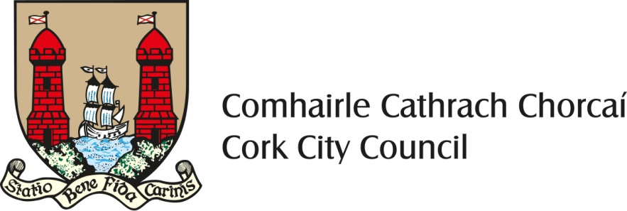
Cork City Council Waste Prevention Grant Scheme 2024
The purpose of the scheme:
This grant is funded by the Community, Culture & Placemaking Directorate of Cork City Council as part of its Waste Prevention Programme and its commitments under the National Waste Management Plan for a Circular Economy 2024-2030 (Ref: National Target 3A 3B 4A 4B. Core Policies CP5 CP7).
This scheme aims to support Cork City groups to implement waste prevention, re-use and repair activities in their local community and to encourage partnership between local schools, social enterprises, charities, community and voluntary groups.
What is Waste Prevention?
Waste prevention is a crucial approach to minimizing the impact of waste on our environment. It involves rethinking our habits and practices to reduce waste generation. Here are some key aspects of waste prevention:
- Rethinking Processes: Instead of following the same old routines, we need to critically evaluate how we do things. By questioning existing practices, we can identify opportunities to reduce waste.
- Redesigning Items: Design plays a significant role in waste generation. By creating products that are durable, repairable, and recyclable, we can minimize waste. Sustainable design principles focus on longevity and resource efficiency.
- Repair and Reuse: Repairing items rather than discarding them helps extend their lifespan. Encouraging repair culture and supporting repair services can significantly reduce waste. Similarly, reusing items (such as clothing, electronics, or containers) prevents the need for new production.
- Community Knowledge and Skills: Empowering communities with knowledge about waste reduction, repair techniques, and sustainable practices is essential. Workshops, educational programs, and skill-sharing initiatives contribute to waste prevention.
- Changing Attitudes and Behaviour: Our consumption patterns and disposal habits impact waste generation. By promoting mindful consumption, encouraging responsible purchasing decisions, and fostering a culture of waste reduction, we can make a difference.
- Collaboration and Creativity: Addressing waste requires collective effort. Communities, social enterprises, governments, and individuals must work together. Creative solutions, innovative technologies, and collaborative projects can lead to effective waste prevention.

Remember, waste prevention is not just about individual actions; it’s a collective responsibility. Let’s think creatively and take steps to reduce waste for a more sustainable future!

Cork City Council may pay a waste prevention grant up to a maximum of €1,500 to voluntary or community groups or schools for waste prevention / reuse / repair / upcycling projects in their local community.
Please note that October is Re-Use month and that successfully funded projects may be requested to show case their results and/or be part of at least one Re-Use Month planned events in Cork City.

How to apply:
- Complete the waste prevention grant application form above.
- The completed application form should be returned to the Environmental Awareness Officer, Community, Culture & Placemaking Directorate for consideration by the closing date Friday 26th of April, 2024.
Post: Environmental Awareness Officer, Community, Culture & Placemaking Directorate, Cork City Council
Email: environmentccp@corkcity.ie
- If you are successful in your application and have not previously received funding from Cork City Council, a new supplier set-up form will need to be completed at https://corkcity.submit.com/show/115 to facilitate direct payment.

Payment of grants:
- The applicants will be informed whether their application has been successful or not by Friday 10th of May 2024.
- 75% of the grant shall be paid at the beginning of the project. Payment of the remaining 25% will be made on submission of a completion report. Grants shall be paid to the name of the organisation specified on the grant application form. Please ensure that this name is the same as the name on the organisation’s bank account.
- Please be advised that any grant that remains unclaimed by 15th December, 2024 will be cancelled.

