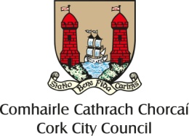

Cork City Centre Placemaking Fund 2022

Overall Aim: Support projects which will enhance, improve, and enliven people’s experience of cork city centre

We are looking for projects which improve public space, inspire visitors and enhance the city centre experience, increase footfall and support the local economy.

We are particularly interested in projects that contributes to the greening of the streets and encourages urban biodiversity in the city centre which may include for example window boxes, hanging baskets, outdoor areas/rooftops with pollinator friendly or edible plants, creating vertical green walls, food towers or installing bird/bat boxes or insect motels. Projects that can demonstrate what is possible in an urban environment or that educate on this topic are welcomed.

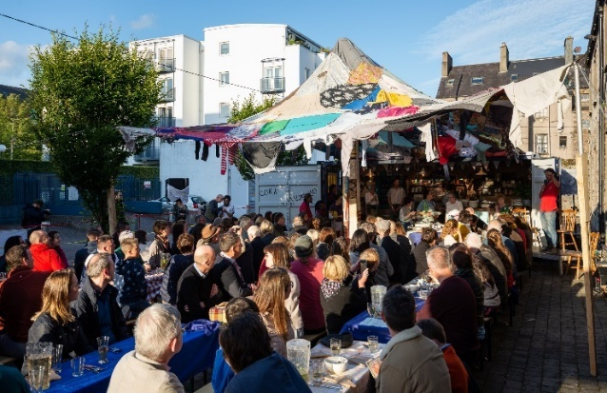
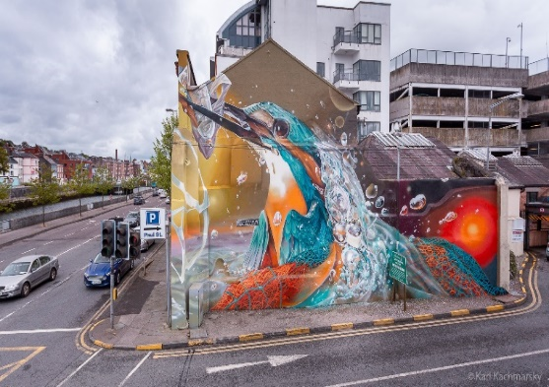
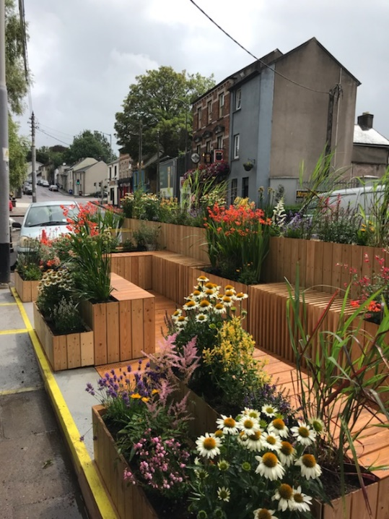 1

Project must deliver one or more of the following outcomes:

- Improved physical appearance of a street/area

- Demonstrate or educate residents/businesses/communities in the city centre as to the potential greening projects that can be undertaken in the city centre

- An improved visitor/resident experience through attractions and interactions

- Improved working partnerships / networks within the city centre between businesses, residents and local communities

- Creation or enhancement of public space which encourage people to stay in the city centre
longer, increase community use and engagement, increase footfall, or increase spend in the city centre

Potential Projects
- Greening/environmental improvement projects

- Atmospheric lighting

- Murals or cultural/artistic attractions

- Unique events which increase liveliness of streets

- Creative public seating

- Other projects which enhance residents/visitors experience of the city centre or particular streets/areas

The Fund
We will fund up to €10,000 towards the cost of an individual project (although many projects may require much less). It will be Cork City Council’s decision on how much is contributed based on the scheme’s objectives. This is primarily a capital fund, although events are also eligible if considered unique and contribute significantly towards the fund’s objectives.

Assessment Criteria & Eligibility

1 - Evidence of need for the project and how this particular project will address the need
2 - Evidence of community and business engagement and support for the project
3 - Evidence of the project’s contribution towards supporting the city centre, the local
economy and the benefits it will bring
4 - Evidence of a well costed and thought through project
5 - Evidence of the projects sustainability following completion
6 - Alignment of the application to the City Centre Strategy/action plan

To be eligible the project (and organisation) must
O Be in Cork City Centre (as defined by City Centre Strategy)
o Lease, own or have written permission from the owner of the land or building where they
wish to carry out a project. This includes relevant Cork City Council directorate where relevant.
o Deliver the project within 12 months of receiving funds
o Contribute to the scheme’s objectives
o Have any necessary permissions, consents or licenses in place required to deliver the
project in advance
o Have sufficient insurance and public liability for the delivery of the project
o Comply with any relevant Health and Safety regulations

Who can apply?
Business Network Groups, individual traders (depending on project) or Community Groups operating within the city centre

Location of proposed project:
The project must be located within the City Centre Core as shown on the map below.
Application Form
Please read Assessment Criteria and Eligibility above before completing this application form.
A separate sheet may be attached with additional information if required.
Closing date for first round of applications is Monday, 30th May 2022

Section A: CONTACT DETAILS

Name of Group: ………………………………………….................................................................................

Address: …………………………………………………………………………….…………..............................................

.............................................................................................................................................................................

Name of Contact Person: .......……………….…….………….……..…………….….................................................

Telephone: ......................................... Email address: ...................................................

Position Held in Group: ....................................................................................................................................

Section B: DETAILS OF PROJECT/ACTIVITY SEEKING FUNDING

Name of Project/Activity: ……………….................................................................................................................

Area that will benefit from the Project/Activity:
.............................................................................................................................................................................
.............................................................................................................................................................................

Details of project/activity: (Please state the purpose for which the funding is required and start and end date of project) .............................................................................................................................................................................
.............................................................................................................................................................................
.............................................................................................................................................................................
.......................................................................................................................................................................................................................................................................................................................................................................................................................................................................................................................................
.............................................................................................................................................................................
………………………………………………………………………………………………...........................................................................
.............................................................................................................................................................................
.............................................................................................................................................................................
.......................................................................................................................................................................................................................................................................................................................................................................................................................................................................................................................................
.............................................................................................................................................................................
.......................................................................................................................................................................................................................................................................................................................................................................................................................................................................................................................................
Details of how the project will be sustained and maintained after completion
.............................................................................................................................................................................
..........................................................................................................................................................................................................................................................................................................................................................

Section C: DETAILS OF EXPENDITURE, FUNDING REQUIRED and OTHER INCOME

EXPENDITURE: Please give a full breakdown of the project costs. Include details of activity, equipment and materials to be funded (please attach quotes if relevant):
.......................................................................................................................................................................................................................................................................................................................................................................................................................................................................................................................................
.............................................................................................................................................................................
.......................................................................................................................................................................................................................................................................................................................................................................................................................................................................................................................................
.......................................................................................................................................................................................................................................................................................................................................................................................................................................................................................................................................

FUNDING REQUIRED:
Total cost of project: €......................................

Amount of PROJECT Grant sought from Cork City Council: €.......................................

Other Income for project: €................................
Source.................................................................................

Section D: DETAILS OF GROUP/ORGANISATION
Explain briefly what your group/organisation does: ...........................................................................................................
.............................................................................................................................................................................
.............................................................................................................................................................................
Explain how your organisation links with other organisations in your area and in the city centre
............................................................................................................................................................................
.............................................................................................................................................................................
.............................................................................................................................................................................

Acknowledgment of Cork City Council’s contribution to the funding of a project will be required in any publicity associated with the project.
Signature of Applicant on behalf of the GROUP:
Name: ....................................................................................................... Date: ..................................
Office held: ……………………………..............………………..……………......................................................

Please complete this form fully, attach all required documentation and return by 30th May 2022 to:

John Hayes
Strategic & Economic Development Section
Cork City Council, City Hall Cork, 021 4924115 or 086 1438535
or email to john_hayes@corkcity.ie (must be under 5mb)

