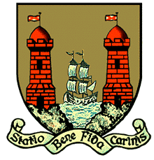
Comhairle Cathrach Chorcaí
Cork City Council

APPLICATION FOR DUPLICATE GRANT OF RIGHT OF BURIAL

Name: ________________________________________________________________ (Applicant)

Address: _______________________________________________________________

I do hereby desire that a duplicate Grant of Right of Burial in

Section _____ Row _____ Plot _____ in St. _____________________ Cemetery be granted to me,

___________________________ (Name) Of ____________________________________

_________________________________________________________________________(Address)

In perpetuity by CORK CITY COUNCIL (being the Burial Bord for the City of Cork), subject to the by-laws governing the cemetery.

Please outline clearly the reason for your application for a duplicate Grant of Right of Burial.

_______________________________________________________________________________________

_______________________________________________________________________________________

_______________________________________________________________________________________

Signed: ______________________________ Date: ___/___/___

Please return to: Parks & Cemeteries | Environment & Recreation Section | Operations Directorate | Cork City Council, Room 112, City Hall, Cork T12 T997, Ireland.
Queries :- 021 492 4000

