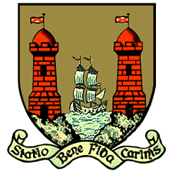

***Comhairle Cathrach Chorcaí***

**Cork City Council**

**ASSIGNMENT OF RIGHT OF BURIAL**

**in _____________________ CEMETERY, CORK.**

*The original Grant of Right of Burial should accompany this assignment.*

I, ___________________________________________________________________________ (Name)

Of ________________________________________________________________________ (Address)

in consideration of the sum of € ____/of natural love and affection, do hereby assign unto:

____________________________________________________________________________ (Name)

of _________________________________________________________________________ (Address)

the exclusive right of burial in **Section _______ Row ______ Plot No. _______**

(as marked and delineated on the Plan of the Cemetery) which was granted to me

in perpetuity, by CORK CITY COUNCIL (being the burial Board for City of Cork),

by deed of Grant No. _______ dated __________and all my estate, title and interest therein to hold

for the remainder of the period for which the same was granted by the said CORK CITY COUNCIL as aforesaid, subject to the conditions of which I held the same immediately before the execution hereof.

Signed: _________________________________

Name: _________________________________ *(Print)*

Address: _________________________________

_________________________________

Telephone: _________________________________

Date: ____/____/____

Please complete accurately and return to:

**Parks & Cemeteries | Environment & Recreation Section | Operations Directorate | Cork City Council, Room 112, City Hall, Cork T12 T997, Ireland.**

**Queries :- 021 492 4000**